Heaton Public School

Student Enrolment

Procedures and Protocols

Contents

Synopsis 3
Managing enrolments in schools 3
Local Enrolment 3
Enrolment cap 4
Local enrolment buffer 4
Non-local enrolment 4
Criteria 5
Enrolment Panel 5
Waiting lists 5
Enrolment time frame 6
Appeals 6
Enrolment application decision tree 6

Document
Version | Author | Date
1.0 | Andrew Hilton | 28/08/2019
Update 2.0 | Andrew Hilton | 08/06/2021

Synopsis
This document supports Heaton School’s implementation of the NSW Department of Education’s Enrolment of Students in NSW Government Schools Policy (July 2019) and should be read in conjunction with the General Enrolment Procedures.

Managing enrolments in schools
A student is entitled to enrol at the local school that the student is eligible to attend if their home is within that school’s local intake area. Parents may apply to enrol their child in the school of their choice. Acceptance is subject to the child being eligible to attend and the school can accommodate the child. (General Enrolment Procedures: 9)
Parents may enrol a child if they turn 5 years of age on or before 31 July in that year. Students identified as gifted and talented, who are aged 4 years or older at 31 January of the year of enrolment may only be enrolled in accordance with the Gifted and Talented policy. (General Enrolment Procedures: 2)
Online Enrolments
Online enrolment for new students is now available at Heaton Public School for both local and out of zone intake. Enrolment applications can be made through our school website under the ‘Enrolment’ tab.

Local Enrolment
To determine if a student’s home is within a school’s local intake area please use the School Finder App by clicking on the button below (Use ‘Control’ and ‘Left Mouse Click’).
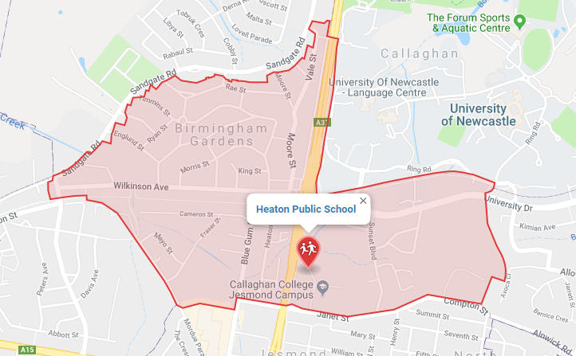
School Finder App

Enrolment cap
Enrolment cap
Buffer level
Enrolment
The Enrolment Cap for a school is established centrally based on permanent accommodation.
The enrolment cap for Heaton Public School is 185.
(General Enrolment Procedures: 9.1)

Local enrolment buffer
Within the enrolment cap, a number of enrolment places (the buffer) must be set aside for the enrolment of local students arriving throughout the year. The size of the buffer will differ in each school based on historical data, enrolment fluctuations and on the number of families moving into or out of the area. The size of the local enrolment buffer is set locally by the principal and approved by the Director, Educational Leadership.
It is reviewed annually and set in time for assessing applications for the following year’s enrolment intake. Places in the local enrolment buffer are not to be offered to non-local students. (General Enrolment Procedures: 9.2)
The Enrolment Buffer for Heaton Public School is 10 students.

Non-local enrolment
Non-local enrolment applications are only considered by schools that can accommodate the child below the set local enrolment buffer level. (General Enrolment Procedures: 9.4)
Except for enrolments at the commencement of the school year, schools that have not reached their local enrolment buffer level should only accommodate non-local enrolments into classes with available places. (General Enrolment Procedures: 9.4)
Non-local enrolment applications include the Application to enrol in a NSW Government school and a non-local enrolment application form. The non-local enrolment application form is developed by the school and requires the applicant to address the selection criteria and provide supporting documentation. (General Enrolment Procedures: 9.4.1)

Criteria
The criteria, listed below, for the enrolment of non-local students has been developed by the Principal, Mr Andrew Hilton, after consultation with the school community. (General Enrolment Procedures: 9.4.2)

- siblings already enrolled at the school
- compassionate circumstances
- medical reasons
- structure and organisation of the school
- proximity and access to the school
- safety and supervision of the student before and after school
- recent change in the local intake area boundaries

Criteria must not include student ability, performance or achievement. Priority should be given to siblings of currently enrolled students, where possible.

Only specialist schools, for example sports or performing arts high schools, may include student ability, performance or achievement in the school’s specialisation within the criteria for non-local enrolment.

It should be made clear what priority is given to each of the criteria. The criteria should be made available to the school community and parents who are interested in enrolling their children. Schools ensure that information about selection criteria, the choice of courses or programs available is accessible in a way that enables the student and parents to make informed choices.

Enrolment Panel
When demand for non-local enrolment exceeds the number of places available below the local enrolment buffer the school will establish an Enrolment Panel to consider all applications against the above criteria. (General Enrolment Procedures: 9.4)

1 | School Executive - Chairperson
2 | Staff member nominated by the Principal
3 | School community member nominated by the school’s parent organisation

Waiting lists
A waiting list may be created for non-local students who are not offered enrolment. Any waiting list created will remain valid during the current intake period only. The waiting list is determined by the enrolment panel. Parents are advised in writing if their child is to be placed on a waiting list and his or her position on it. The length of the waiting list should reflect realistic expectations of potential vacancies. (General Enrolment Procedures: 9.4.4)

Enrolment time frame
It is anticipated that enrolment of students should not exceed 10 days from receipt of completed Application to Enrol in a NSW Government School. Where circumstances indicate that this timeframe may not be met Principals are require to consult their Director, Educational Leadership.

Appeals
Unsuccessful non-local applicants may appeal against the decision of the enrolment panel. The appeal is made in writing to the principal and sets out the grounds of the appeal. If necessary, the principal should provide or arrange assistance, such as an interpreter, to enable the appeal to be set out in writing. The purpose of the appeal is to determine whether the stated criteria have been applied equitably. If the principal is not on the enrolment panel, the principal considers the appeal and makes a determination. Otherwise, the appeal may be determined by the Director, Educational Leadership. (General Enrolment Procedures: 9.4.5)

Enrolment application decision tree

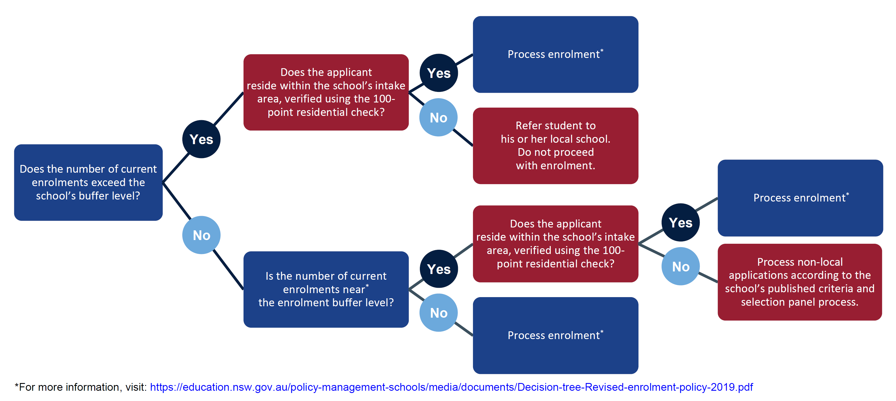

Director’s Endorsement
Heaton Public School

Year | 2021
Enrolment Cap | 185
Buffer | 14
Approaching Buffer – Non Local Enrolments requiring Director approval.
When the school’s enrolment level is close to the local enrolment buffer, the principal is required to inform the principal of the child’s local school when considering the non-local enrolment application, and to seek approval of the Director, Educational Leadership before making an offer to enrol the child.

I confirm my endorsement of the figures identified above.

Signature: _______________________________________________

Josie Bailey
Director,
Educational Leadership
Callaghan Network

June 2021

